**Systems:**

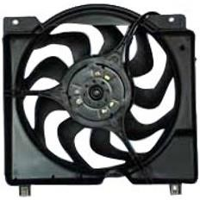

JEEP CHEROKEE XJ

A MECHATRONIC

SYSTEM



**Control**

**Systems:**

**Mechanical**

Description of system:

The Jeep Cherokee XJ is a "sport utility vehicle" with many

mechanical, electrical,

computer controlled

systems. The XJ

is designed for general transportation of people and cargo as

well as adventures of off

-

roading and overlanding.

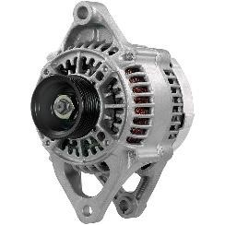

Alternator

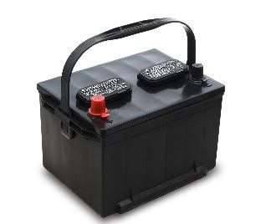

**Electrical**

**System:**

x

Diodes and voltage

Regulator

Converts it to 12Vdc

150Amps – 1800W

2.4HP

Wires

Battery

Temp sensor

ECM

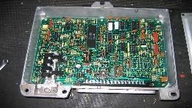

ECM

12

Vdc

~16Amps

Radiator Fan

12

Vdc

~60Amps

~3500RPM

Battery

12

Vdc

~150Amps

Radiator Fan

Alternator

Power source:

Chemical energy

Output power:

Ph AC

3